Credit Card Approval Prediction

Project Description:
Credit Card Approval Prediction is a machine-learning-powered web application that gives an applicant an instant estimate of their credit card approval odds based on three details: their income type, education level, and annual income. The platform includes a Data Exploration & Pre-processing pipeline that cleans applicant records and encodes categorical fields, a Model Comparison module that trains and evaluates Logistic Regression, Random Forest, and Decision Tree classifiers, and a Flask web application with a live credit-card preview that reveals a generated, Luhn-valid card number on approval.
Built entirely with Python, Flask, and scikit-learn, the platform trains on application_record.csv and saves the trained models together with their LabelEncoders and feature order into a single model.pkl bundle, so the web app always encodes and predicts consistently with how the models were trained. With no persistent user data, no login requirement, and a clearly documented synthetic training label (since the source data has no real approval outcome), CaptionAI's counterpart here — the Approval Estimator — gives applicants, students, and demo audiences a fast, transparent way to see how income and background factors could influence a credit decision.
Repository: https://github.com/Divisukumar3010/Credit-card-approval-SmartBridge

Scenarios:
Scenario 1: A salaried professional working a full-time job enters their name, selects "Working" as income type, "Higher education" as education, and an annual income of ₹8,00,000. The system encodes these values, runs them through the trained Random Forest model, and returns "Credit Card Approved" along with a generated 16-digit card number revealed on a stamped result page.
Scenario 2: A student with no steady income selects "Student" as income type, "Secondary / secondary special" as education, and a low annual income figure. The model estimates lower approval odds given the income and income-type profile, and the result page shows "Credit Card Rejected" with a masked, unissued card number, since no card is generated for a declined application.
Scenario 3: A pensioner with a moderate, stable income selects "Pensioner" as income type and "Academic degree" as education. The live card preview updates in real time as they type, and on submission they see an approval decision alongside a receipt-style breakdown of the exact income type, education, and income figure that were evaluated.

Technical Architecture:
The Credit Card Approval Prediction uses a simple two-tier architecture: a presentation layer (HTML, CSS, and vanilla JavaScript rendered via Flask/Jinja2 templates) and an application layer (Flask + scikit-learn) that validates form input, encodes categorical fields using saved LabelEncoders, runs the trained classification model, and — on approval — generates a Luhn-valid card number. There is no database: training data is read from flat CSV files, and the trained model, encoders, and feature order are persisted together in a single pickled file (model.pkl) loaded once at application startup.
Data flow: Applicant submits the form → Request Handling validates input → Encoding transforms income type/education using the saved encoders → Prediction runs the selected model (Random Forest by default, configurable via the MODEL_NAME environment variable) → Card Issuance generates a card number only if approved → result is rendered back to the applicant.
Note: this project does not use a database, so no ER Diagram is included — applicant data is neither queried nor persisted beyond a single request/response cycle.

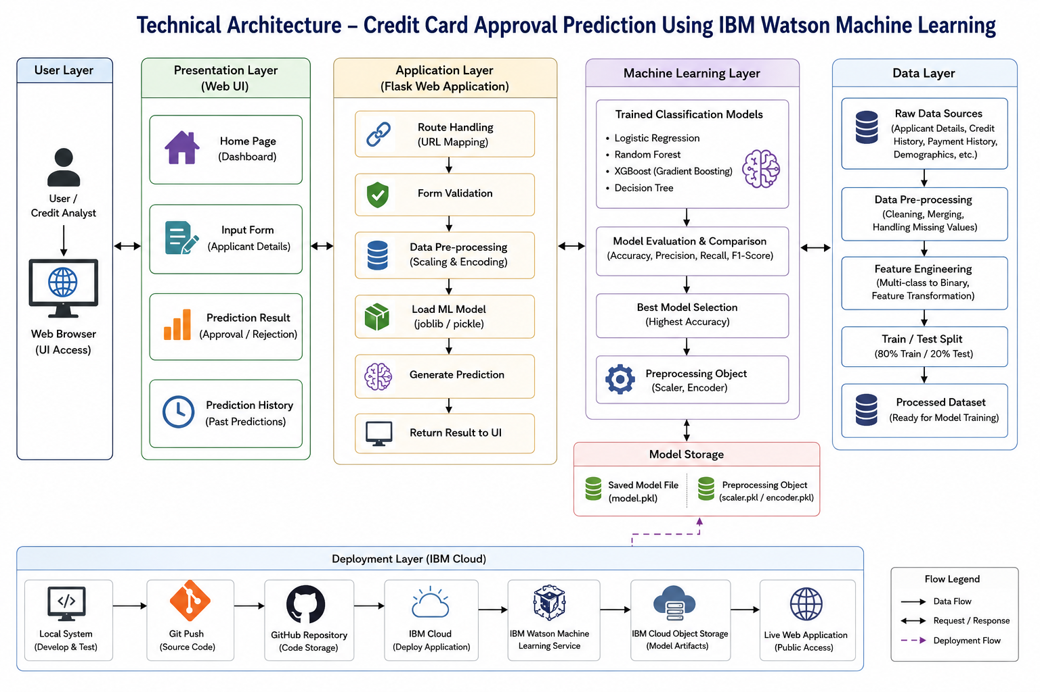

Pre-requisites:
- Flask Framework Knowledge: https://flask.palletsprojects.com/
- scikit-learn Familiarity: https://scikit-learn.org/stable/
- HTML, CSS, and JavaScript Skills: https://www.w3schools.com/
- Python Programming Proficiency: https://docs.python.org/3/
- Pandas & NumPy for Data Handling: https://pandas.pydata.org/docs/
- Version Control with Git: https://git-scm.com/doc
- Jupyter Notebook Environment: https://jupyter.org/documentation

Project Workflow:

Milestone 1: Data Exploration and Visualization
This milestone focuses on understanding the raw applicant data before any modeling begins — verifying data shape, exploring category distributions, and checking relationships between income and applicant attributes.

Activity 1.1: Load the Datasets
- Read application_record.csv and creditcard.csv with pandas and confirm their shapes.
app = pd.read_csv('application_record.csv')
credit = pd.read_csv('creditcard.csv')

print('application_record.csv shape:', app.shape)
print('creditcard.csv shape:', credit.shape)

Activity 1.2: Univariate Analysis
- Plot the distribution of AMT_INCOME_TOTAL (clipped at the 99th percentile to reduce outlier skew).
- Count applicants by NAME_INCOME_TYPE, NAME_EDUCATION_TYPE, and CODE_GENDER.

Activity 1.3: Multivariate Analysis
- Boxplot income by income type and by education type to see how income varies across categories.
- Correlation heatmap across the numeric applicant fields.

Activity 1.4: Descriptive Analysis
- Run .describe() on numeric and categorical columns, check missing-value percentages, and compute income skew.

Milestone 2: Data Pre-processing
Milestone 2 cleans the applicant data and builds a genuine, documented training target — since neither source dataset contains a real "approved / rejected" column.

Activity 2.1: Drop Duplicate Records and Handle Missing Values
- Drop duplicate applicant rows based on the full set of demographic/financial columns.
- Fill or drop missing values in the fields the app actually uses: NAME_INCOME_TYPE, NAME_EDUCATION_TYPE, AMT_INCOME_TOTAL.

Activity 2.2: Build a Synthetic Approval Label
creditcard.csv is an unrelated, anonymized fraud-transaction dataset (Time, V1...V28, Amount, Class) that does not share an ID space with application_record.csv — an earlier attempt to merge the two by row position produced a meaningless single-class label. Instead, a rule-based synthetic label is built directly from the applicant data, with random noise mixed in so the pattern isn't a perfectly clean lookup table:

rng = np.random.default_rng(42)

income_median = app_features['AMT_INCOME_TOTAL'].median()
strong_income_type = {'Working', 'Commercial associate', 'State servant'}
strong_education = {'Higher education', 'Academic degree'}

score = (
(app_features['AMT_INCOME_TOTAL'] >= income_median).astype(int)
+ app_features['NAME_INCOME_TYPE'].isin(strong_income_type).astype(int)
+ app_features['NAME_EDUCATION_TYPE'].isin(strong_education).astype(int)
)

final_df['APPROVED'] = (score >= 2).astype(int)
noise_mask = rng.random(len(final_df)) < 0.12
final_df.loc[noise_mask, 'APPROVED'] = 1 - final_df.loc[noise_mask, 'APPROVED']

Activity 2.3: Encode Categorical Fields
Two LabelEncoders are fit — one for income type, one for education — and saved alongside the models so app.py can encode form input identically at inference time.
income_type_encoder = LabelEncoder()
education_type_encoder = LabelEncoder()

final_df['INCOME_TYPE_ENC'] = income_type_encoder.fit_transform(final_df['NAME_INCOME_TYPE'])
final_df['EDUCATION_TYPE_ENC'] = education_type_encoder.fit_transform(final_df['NAME_EDUCATION_TYPE'])

Milestone 3: Model Building
Three classification models are trained on the same three-feature schema — income type, education, and annual income — and compared using accuracy and a full classification report.

Activity 3.1: Train / Test Split
FEATURE_ORDER = ['INCOME_TYPE_ENC', 'EDUCATION_TYPE_ENC', 'AMT_INCOME_TOTAL']
X = final_df[FEATURE_ORDER]
y = final_df['APPROVED']

X_train, X_test, y_train, y_test = train_test_split(
X, y, test_size=0.2, random_state=42, stratify=y
)

Activity 3.2: Train and Evaluate Logistic Regression, Random Forest, and Decision Tree
- Each model is fit on the training split and evaluated on the test split with accuracy_score and classification_report.
- Random Forest is used as the default model in the deployed app, selectable via the MODEL_NAME environment variable.

Activity 3.3: Save the Models and Encoders
bundle = {
'models': {
'logistic_regression': lr_model,
'random_forest': rf_model,
'decision_tree': dt_model,
},
'income_type_encoder': income_type_encoder,
'education_type_encoder': education_type_encoder,
'feature_order': FEATURE_ORDER,
}

with open('model.pkl', 'wb') as file:
pickle.dump(bundle, file)

Milestone 4: Application Development
Milestone 4 builds the Flask application that serves the trained model behind a form-based interface, styled around a live credit-card preview.

Activity 4.1: Define the Core Routes in app.py
@app.route('/')
def home():
return render_template('index.html')

@app.route('/predict', methods=['POST'])
def predict():
applicant_name = request.form.get('applicant_name', 'Applicant')
income_type = request.form.get('income_type', '')
education_type = request.form.get('education_type', '')
annual_income = float(request.form.get('annual_income', ''))
...

Activity 4.2: Encode Form Input Consistently with Training
def encode_category(encoder, value, field_label):
if value in encoder.classes_:
return int(encoder.transform([value])[0])
fallback = encoder.classes_[0]
print(f"Warning: unseen {field_label} '{value}', falling back to '{fallback}'")
return int(encoder.transform([fallback])[0])

Activity 4.3: Generate a Realistic, Luhn-Valid Card Number on Approval
A card number is only generated when the application is approved, seeded deterministically from the applicant's details so resubmitting the same inputs always yields the same number:
def luhn_check_digit(digits):
total = 0
for i, d in enumerate(reversed(digits)):
if i % 2 == 0:
d *= 2
if d > 9:
d -= 9
total += d
return (10 - (total % 10)) % 10

def generate_card_number(seed_text):
seed = int(hashlib.sha256(seed_text.encode()).hexdigest(), 16)
rng = random.Random(seed)
prefix = rng.choice(['4', '51', '52', '53', '54', '55'])
digits = [int(d) for d in prefix]
while len(digits) < 15:
digits.append(rng.randint(0, 9))
digits.append(luhn_check_digit(digits))
number = ''.join(str(d) for d in digits)
return ' '.join(number[i:i + 4] for i in range(0, 16, 4))

Activity 4.4: Build the Live Card Preview (Frontend)
- index.html includes a JavaScript listener that updates the card holder name, income-type tier badge, and a masked number preview as the applicant types.
- result.html reuses the same card component, adding a rotated stamp ("Approved"/"Declined") and a receipt-style breakdown of the submitted income type, education, and income.

Milestone 5: Documentation and Repository Setup

Activity 5.1: Write Project Documentation
- A README.md documents the project structure, setup steps, the synthetic-label caveat, and how prediction works end-to-end.

Activity 5.2: Push the Project to a Git Repository
All source files — main.ipynb, app.py, templates/, and README.md — are committed to: https://github.com/Divisukumar3010/Credit-card-approval-SmartBridge

Activity 5.3: Run the Application Locally
pip install flask scikit-learn pandas numpy matplotlib seaborn
# Run main.ipynb top to bottom to generate model.pkl and the app files
python app.py
# Open http://127.0.0.1:5000 in your browser

Exploring the Website's Web Pages:

Home / Application Page:
The home page presents a two-column layout: a ledger-style form on the left collecting the applicant's name, income type, education, and annual income, and a live credit-card preview on the right that updates in real time as each field is filled in. The design uses a deep navy/gold palette with a serif display face and a monospace font for the card number, giving the page a financial, statement-like feel rather than a generic form.

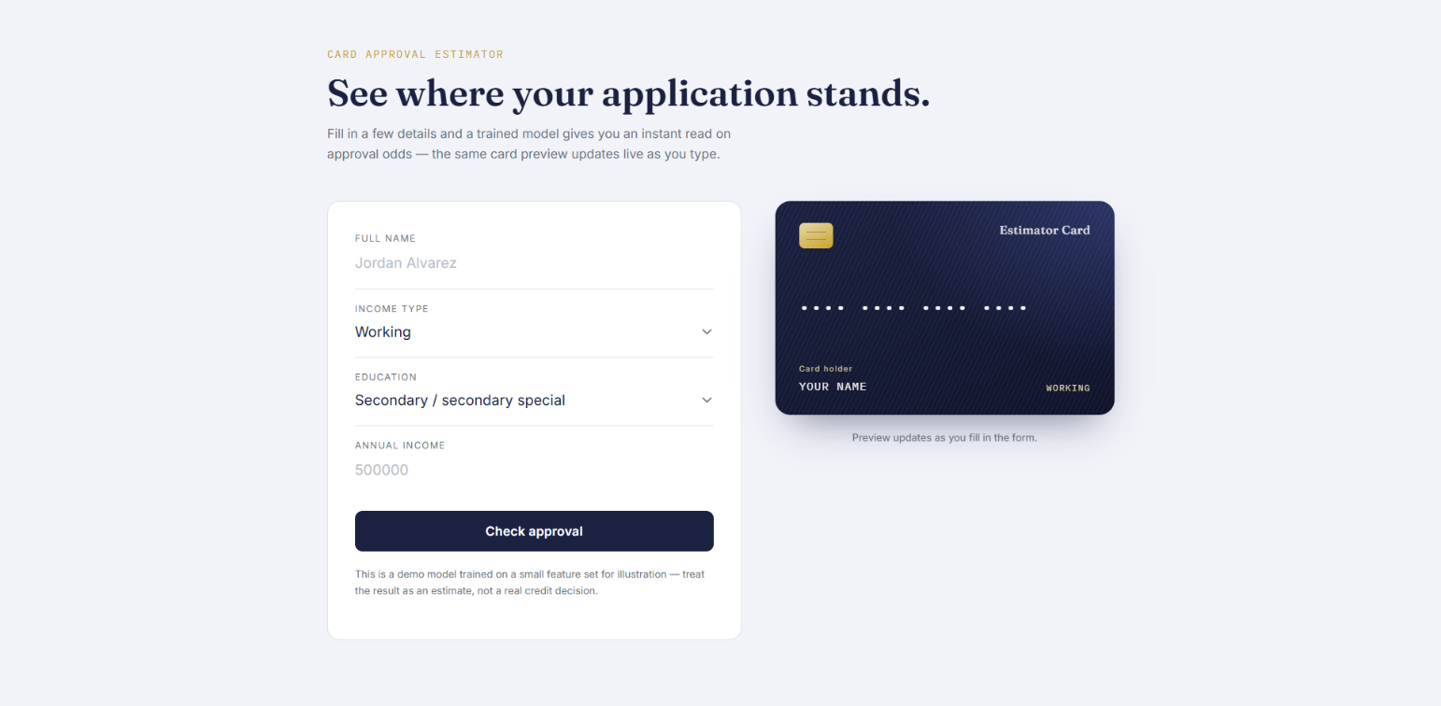

Result Page:
After submission, the same card component reappears with a rotated ink-stamp overlay reading "Approved" or "Declined." Beneath the card, a receipt-style breakdown lists the exact income type, education, and income figure that were evaluated. Approved applications reveal a full 16-digit, Luhn-valid card number; declined applications keep the number masked, since no card is issued.
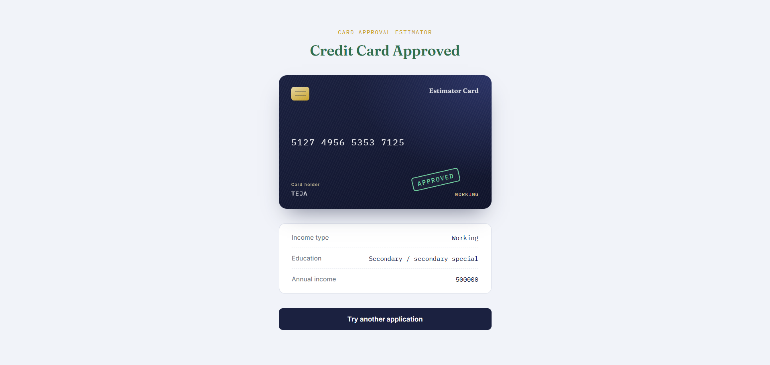

Credit card declined:

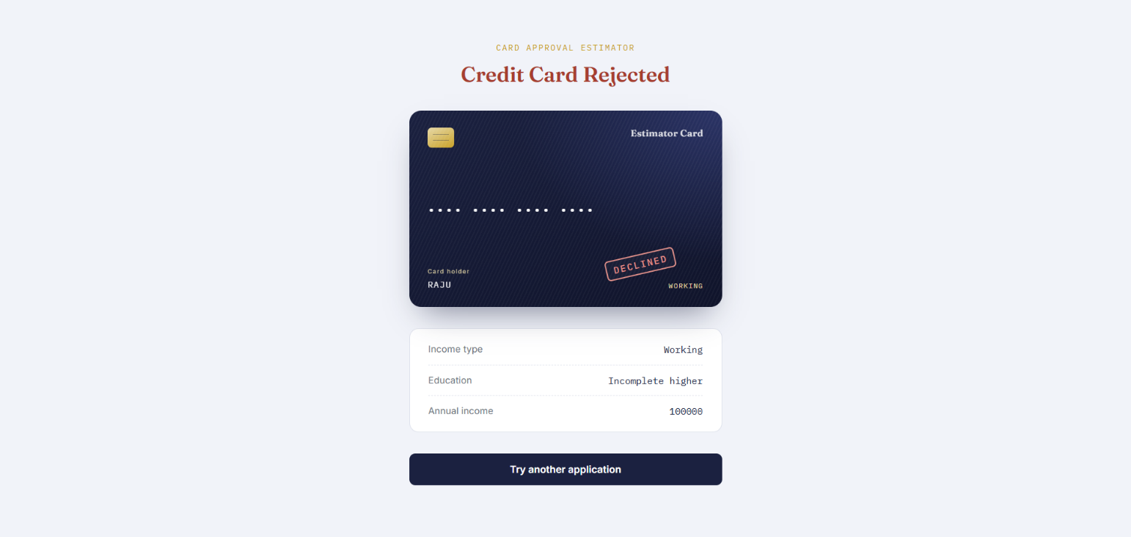

Conclusion:
The Credit Card Approval Prediction is a Flask-based machine learning application that gives applicants an instant, transparent estimate of their credit card approval odds from three simple inputs — income type, education, and annual income. It compares Logistic Regression, Random Forest, and Decision Tree classifiers, bundles the winning model together with its encoders for consistent inference, and wraps the result in a distinctive live credit-card preview UI. Because the source datasets contain no genuine approval outcome, the project is transparent about using a documented synthetic label for training, making it best suited as a demonstration and learning project rather than a real underwriting tool. Looking ahead, the platform could be extended with a real approval dataset, additional applicant features (family status, housing type, employment length), user authentication to save past applications, and a production deployment — evolving it from a self-contained demo into a fuller credit-risk exploration tool.

